**Question set 1a – C++ Review.**

Every C++ program has a function called _________.



The function main returns an ___integer_______.



Built-in data types are also called __________. primitives

An int data type is a built-in data types T or F?



A float data type is a built-in data types T or F?

A micro data type is a built-in data types T or F?



Before an identifier (name) can be used it must be __________.



The insertion operator << used for __________.



Extraction operator >> used for __________.



__________ is the newline operator.



For us to use tools for accessing data files, we use #include __________



Concerning data files, use __________ to prepare stream for use.



Concerning data files, use __________ to break the connection between the stream and the variable when you are done with the stream.



The statement intVar = int(floatVar); is an example of __________. (3 words)

The body of a __________ may never execute.



A sentinel-controlled loop is looking for a marker called a __________ to tell it to stop the loop. flag

An __________ Controlled Loop is looking for the operating system End-Of-File marker to indicate the end of the data to be processed.



The __________ statement is intended to simplify the writing of count controlled loops.



When a loop is contained inside another loop, we call this a __________ loop.



----------------------------------------------------



#include <iostream>

using namespace std;

int main()

{

int a=1;

int b=10;

int c=1;

for(i=a, i<=b, i=i+c)

{

cout << “Ding” << endl;

}

return 0;

}

----------------------------------------------------

Given the above program and leaving a=1, b=10 and c=1 how many times will the word Ding be printed? __________

Given the above program and changing the lines to read a=1, b=18 and c=2 how many times will the word Ding be printed? __________

Given the above program and changing the lines to read a=6, b=18 and c=3 how many times will the word Ding be printed? __________

Given the above program and changing the lines to read a=6, b=19 and c=3 how many times will the word Ding be printed? __________

Given the above program and changing the lines to read a=20, b=18 and c=2 how many times will the word Ding be printed? __________

Note: using the For statement demo on the [w3schools.com](https://www.w3schools.com/cpp/trycpp.asp?filename=demo_for_loop) website, change the screen to match the code below.

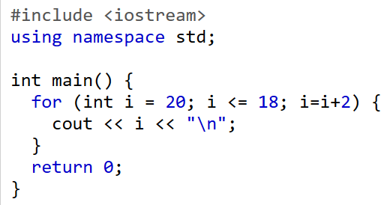

The body of a __________ *will* execute at least 1 time.



When your running program gets to a __________ statement, it causes an immediate exit from the innermost switch, while, do-while, or for statement in which it appears.



----------------------------------------------------

#include <iostream>

using namespace std;

int main()

{

char letterGrade;

cout << “Input your letter grade now: ” << endl;

cin >> letterGrade; // Input grade as a character

switch (letterGrade)

{

case ‘A’ : cout << “Numeric Equivalent = 4.0”;

break;

case ‘B’ : cout << “Numeric Equivalent = 3.0”;

break;

case ‘C’ : cout << “Numeric Equivalent = 2.0”;

break;

case ‘D’ : cout << “Numeric Equivalent = 1.0”;

break;

case ‘F’ : cout << “Numeric Equivalent = 0.0”;

break;

default : cout << “Unrecognized letter grade”;

}

return 0;

}

----------------------------------------------------

You are given the program above. You run the program. When prompted, you enter the letter ‘B’. What is the output?



You are given the program above. You run the program. When prompted, you enter the letter ‘T’. What is the output?



A __________ is a block of code which only runs when it is called.



You can receive __________ as a result from a function. information

Functions are important for __________. Define the code once, and use it many times.



There are three components to a C++ function. The __________ is a declaration of the identifier used to name the function.



There are three components to a C++ function. The __________ contains the statements that perform that function’s task.

There are three components to a C++ function. The __________ appears in the client code and is used to invoke a particular function.



There are two types of C++ functions. __________ functions do not return any information from the function.



There are two types of C++ functions. __________ functions do return information from the function.